**“Week 8 Project”**

Sudip Poudel

Kushal Ramjali

Ankit Pandey

International American University (IAU)

CSE 220 PRINCIPLES OF SOFTWARE ENGINEERING

Professor Aryal

August 24, 2025

**Clinic Appointment Management System (CAMS)**

**Team Members:** Sudip Poudel, Ankit Pandey, Kushal Ramjali

* **Project Duration:** September 2025
* **Methodology:** Agile Scrum
* **Tools Used:** Trello (task management), GitHub (version control), Excel/Sheets (test cases), draw.io (UML diagrams)

**1. Introduction**

The **Clinic Appointment Management System (CAMS)** is designed to simplify and automate the process of booking and managing appointments in a clinic.

**System Users:**

* **Patients:** Register, log in, view doctors, book/cancel appointments, view history, and give feedback.
* **Doctors:** View schedules, update availability, and receive notifications for cancellations.
* **Admins:** Manage patient and doctor records, oversee schedules, generate reports, and ensure system reliability.

**Objectives:**

1. Simulate Agile-based software development practices.
2. Demonstrate the complete SDLC (requirements → design → development → testing → documentation).
3. Encourage teamwork using version control and project management tools.
4. Highlight realistic workflow challenges (e.g., weekends, delays, and sprint adjustments).

**2. Team Roles**

|  |  |  |
| --- | --- | --- |
| **Member** | **Role** | **Responsibilities** |
| **Ankit Pandey** | Frontend & Requirement Analyst | Patient-facing features, registration, UI design, initial backlog creation |
| **Sudip Poudel** | Backend & Design Engineer | Booking logic, database integration, UML diagrams, GitHub updates |
| **Kushal Ramjali** | Tester & Documentation Lead | Testing, Trello board management, final report, admin features |

**3. Agile Process**

**3.1 Product Backlog (User Stories)**

|  |  |  |  |
| --- | --- | --- | --- |
| User Story ID | User Story | Priority | Story Points |
| US01 | As a patient, I want to register so I can book appointments | High | 3 |
| US02 | As a patient, I want to log in securely | High | 3 |
| US03 | As a patient, I want to book appointments online | High | 5 |
| US04 | As a doctor, I want to view my schedule | Medium | 3 |
| US05 | As a patient, I want to view my appointment history | Medium | 2 |
| US06 | As an admin, I want to manage doctor schedules | High | 5 |
| US07 | As an admin, I want to generate reports | Low | 2 |
| US08 | As a patient, I want to cancel appointments | High | 3 |
| US09 | As a patient, I want notifications for updates | Medium | 2 |
| US10 | As a patient, I want to give feedback on visits | Low | 1 |

**3.2 Sprint Planning**

|  |  |  |  |  |  |  |
| --- | --- | --- | --- | --- | --- | --- |
| Sprint | User Story | Task | Assigned To | Priority | Start | End |
| Sprint 1 | US01 | Design registration form | Sudip | High | 2025-09-01 | 2025-09-02 |
|  | US01 | Implement backend logic | Ankit | High | 2025-09-03 | 2025-09-04 |
|  | US01 | Test registration | Kushal | Medium | 2025-09-05 | 2025-09-06 |
| Sprint 2 | US03 | Design booking interface | Sudip | High | 2025-09-09 | 2025-09-10 |
|  | US03 | Implement booking logic | Ankit | High | 2025-09-11 | 2025-09-13 |
|  | US03 | Integrate booking with patient data | Kushal | Medium | 2025-09-14 | 2025-09-15 |
| Sprint 3 | US06 | Design admin dashboard | Sudip | High | 2025-09-18 | 2025-09-19 |
|  | US06 | Implement schedule management | Ankit | High | 2025-09-20 | 2025-09-22 |
|  | US06 | Test admin module | Kushal | Medium | 2025-09-23 | 2025-09-24 |

**4. Trello Board Layout**

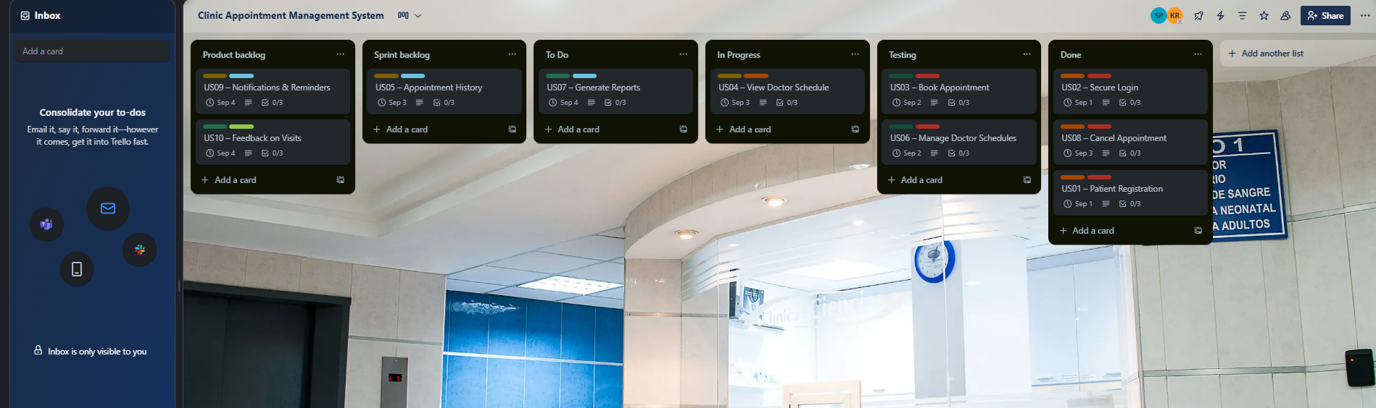

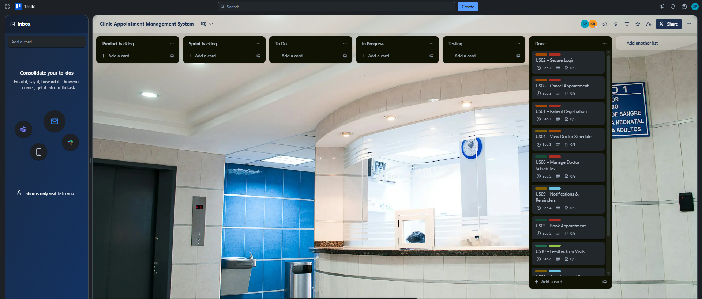

Fig 1: Sprint planning in trello

**5. UML Diagrams:**

* **Use Case Diagram:** Patient, Doctor, Admin interactions

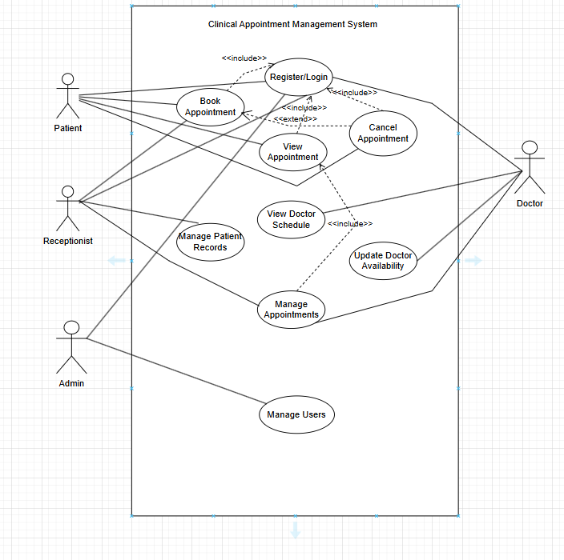

FIG 2: Use case diagram for CAMS

* **Class Diagram:** Entities: Patient, Doctor, Appointment, Admin, Schedule

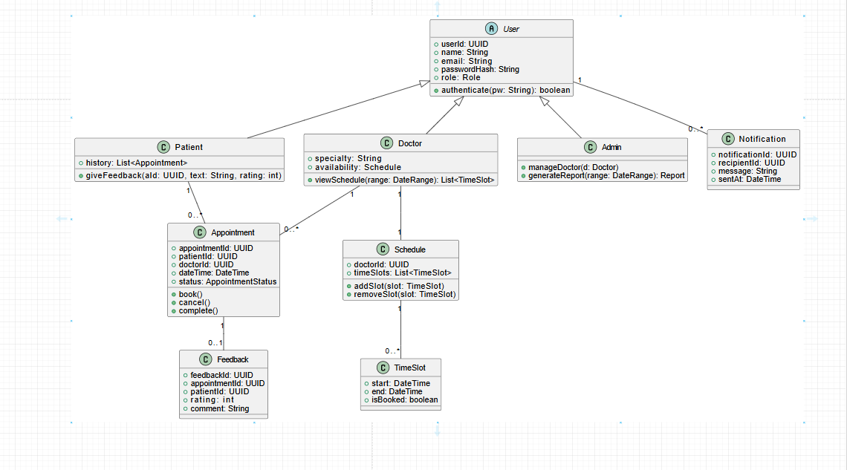

Figure 3.0: Class diagram for CAMS

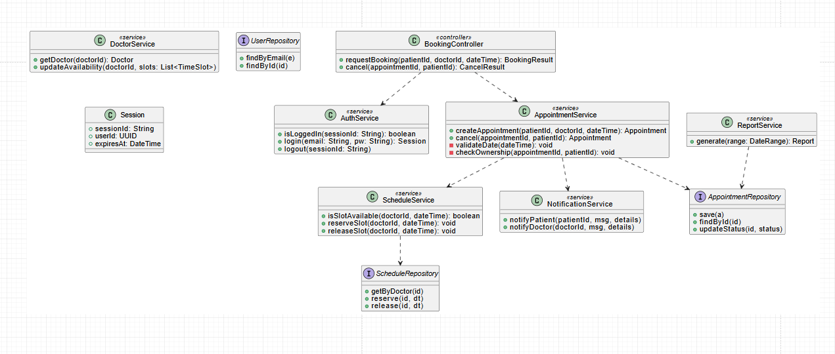

Figure 3.1: Class diagram for CAMS

* **Sequence Diagram:** Steps in booking an appointment

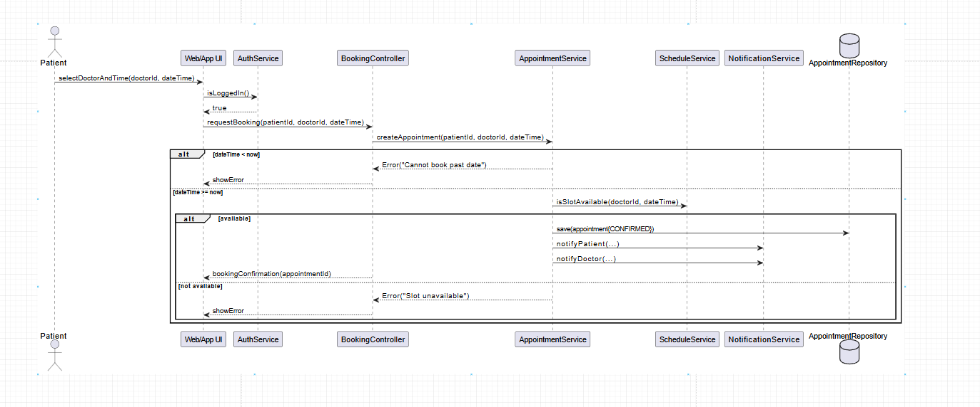

Figure 4.0: Sequence diagram for CAMS

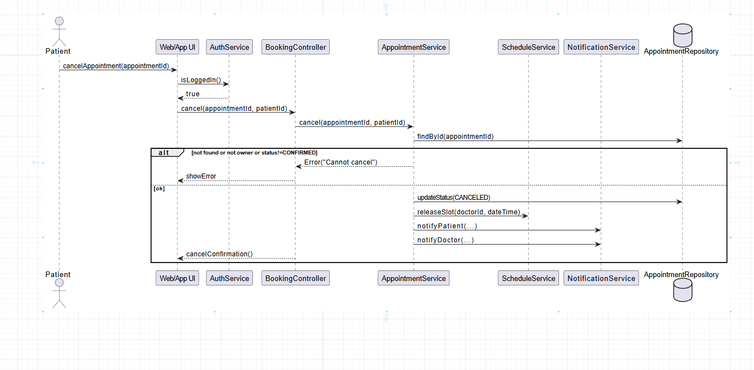

Figure 4.1: Sequence diagram for CAMS

* **Activity Diagram:** Workflow: Login → Booking → Confirmation

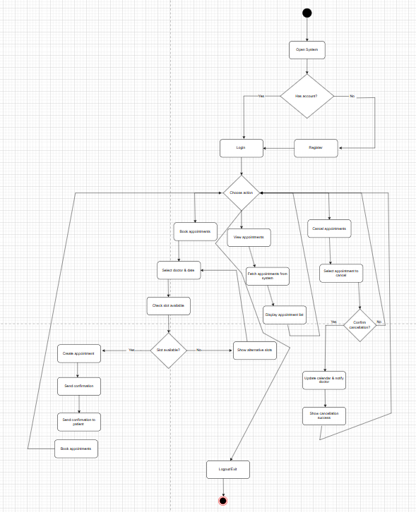

FIG 5: Activity diagram for CAMS

**6. Test Case Matrix**

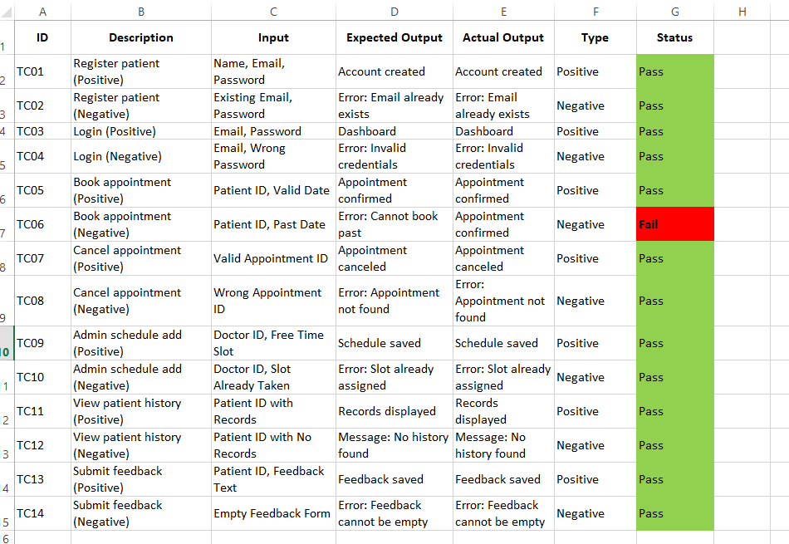

Fig 6: Testing

**7. Gantt Chart (SDLC Stages)**

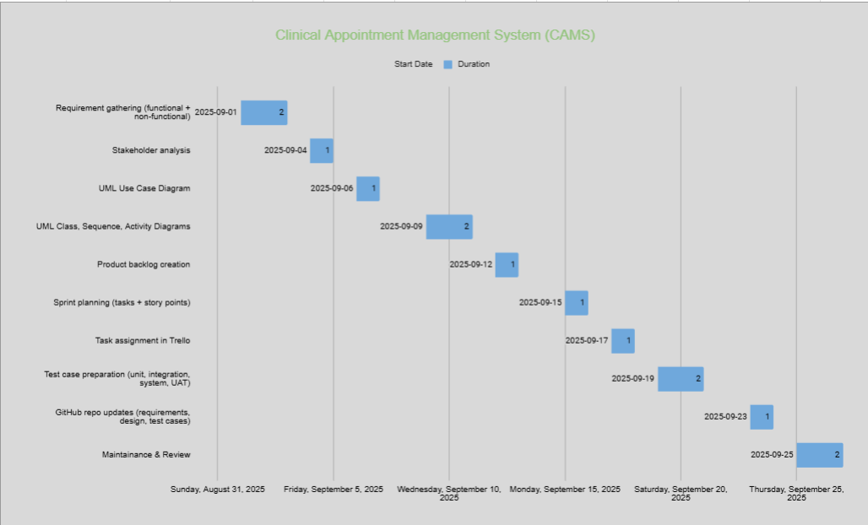

Fig 7: Overall Project duration in Gantt chart

**8. GitHub Repository Structure**

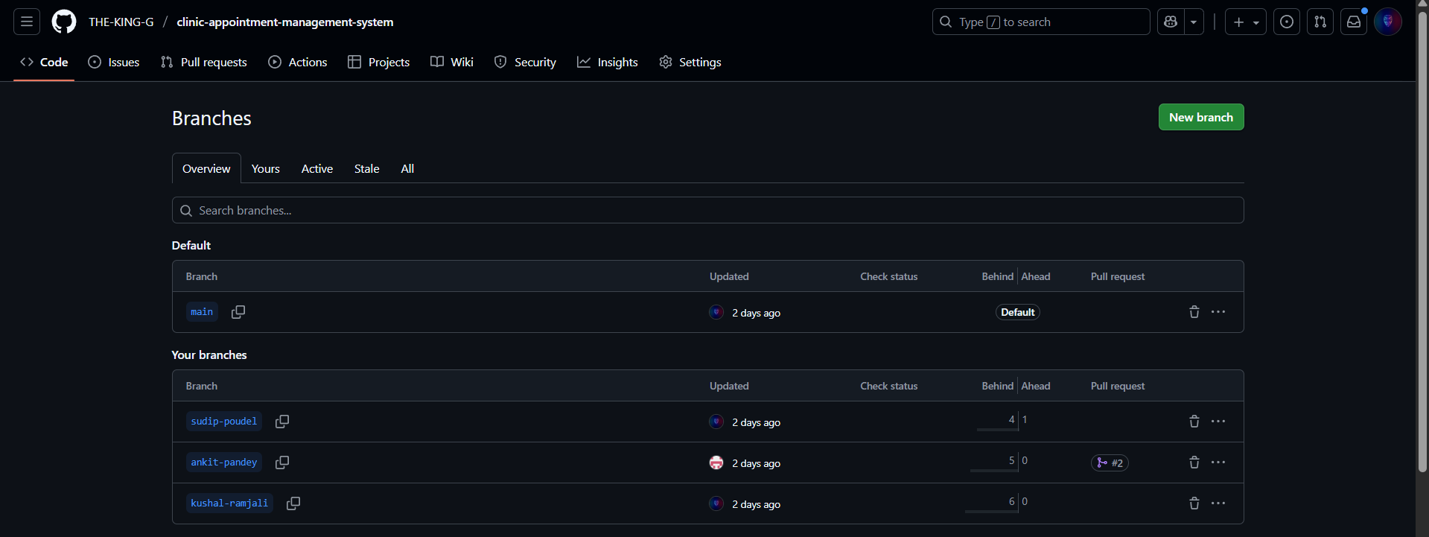

Fig 8: Main branch with 3 different branches for team collabaration

**Branches:** Sudip-Poudel, Ankit-Pandey, Kushal-Ramjali

**Commit Examples:**

* “Added patient registration form”
* “Implemented booking backend”
* “Fixed login bug”

Github repo link:

<https://github.com/THE-KING-G/clinic-appointment-management-system>

**9. Reflection**

* **Sudip:** Gained experience in backend design, UML diagrams, and GitHub collaboration.
* **Ankit:** Improved frontend/UI design and requirement analysis.
* **Kushal:** Strengthened testing, documentation, and QA management.

**Team Learning:**

* Practical Agile sprint planning with weekend gaps.
* Hands-on collaboration using Trello and GitHub.
* Realistic understanding of SDLC with testing and deployment challenges.

In conclusion, through this project, we learned how to manage a software project using Agile practices. We gained hands-on experience with tools like Trello for sprint planning and GitHub for version control. By preparing UML diagrams, a Gantt chart, and test cases, we understood how different phases of the Software Development Life Cycle (SDLC) connect together. Working in a team helped us divide tasks according to roles, coordinate better, and handle delays realistically. Overall, this project taught us both technical and teamwork skills that will be useful in real-world software engineering.

**References**

Sommerville, I. (2016). *Software Engineering* (10th ed.). Pearson.

Schwaber, K., & Sutherland, J. (2020). *The Scrum Guide*. Scrum.org.

Cohn, M. (2004). *User Stories Applied*. Addison-Wesley.